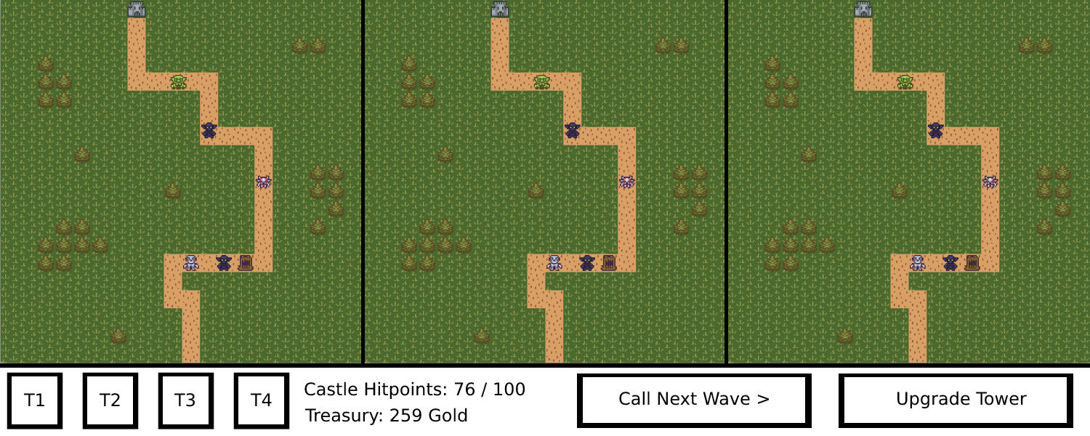

Much of the screen will be taken up by the three layers. In the example above all three look the same, but in the proper version there will be different ground textures and path layouts.

On the bottom left there are buttons for each of the towers the player can build. Once clicked, the player can hover his mouse over any part of the map, and there will be a square overlaid at the mouse pointer. This square is green if the tower may be built at that position. If the player does not have the gold, there is already a tower there or he is hovering above a path tile, then the square is red.

If the square is green, then the player can use another left click to build the tower at his mouse’s current position. He or she may also at any time cancel his build action by right clicking.

Next to the tower buttons, there are two none-interactive labels that show the players remaining hit points as well as his accumulated gold.

On the bottom right, there are two large buttons that are both unclickable by default. The call next wave button gets enabled once all enemies of the current wave have been destroyed. Clicking on it prompts the next wave to begin.

The tower upgrade button gets enabled when the player has selected a tower on one of the layers by left clicking on it and he or she has enough gold to afford the tower upgrade.